Please feel free to adapt this template to suit your needs.

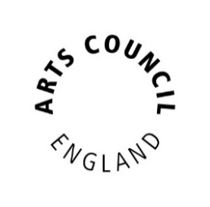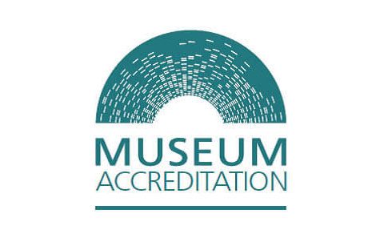

Date of issue: [Insert date]

[Insert museum name] AWARDED
ACCREDITATION ACCOLADE

[Insert short summary of who the museum is , what they do and which audiences they engage with]

Administered by Arts Council England on behalf of the UK Accreditation Partnership, Accreditation is the benchmark for well-run Museums and Galleries.

It means that [insert museum name] is properly managed and governed to the nationally agreed industry standard and shows the museum takes proper care of its collections, sharing them with visitors and keeping them safe for future generations.

Accreditation opens up exciting funding opportunities, allows museums to host touring exhibitions and gives access to professional advice and support. It also gives confidence to donors and sponsors who may wish to support the museum in preserving heritage and inspiring future generations.

Accreditation covers museums of all types and sizes - from the smallest volunteer-run museums to national museums – and more than 1,700 museums are currently taking part in the scheme across the UK.

More information about the Accreditation scheme can be found here.

[Insert NAME, JOB TITLE at MUSEUM], said:
"[Insert supportive quote]"

Emmie Kell, Director Museums and Cultural Property at Arts Council England said: "We’re delighted that XXX has been successful in gaining their Accreditation status. This means that their Collections will be looked after and maintained offering inspiration, enjoyment and learning for the local community and visitors to enjoy now and in the future.”

For more information, please contact:
[Insert contact details]

Notes to Editors

[Insert museum's boilerplate]

About Arts Council England

Arts Council England is the national development agency for creativity and culture. We have set out our strategic vision in Let’s Create that by 2030 we want England to be a country in which the creativity of each of us is valued and given the chance to flourish and where everyone of us has access to a remarkable range of high-quality cultural experiences. From 2023 to 2026 we will invest over £467 million of public money from Government and an estimated £250 million from The National Lottery each year to help support the sector and to deliver this vision.

